Owners’ Association
Mountain Gate HOA Annual Meeting Minutes

Date and Time: 05/19/2020, 7:30 PM
Location: Zoom Teleconference Online
Board Members Present: Bill Lazar, Rob Marreel, Glen Hanna, Matt Kleinke, Aaron Reiter

General
The meeting started with an introduction and welcome by our President Rob Marreel. There were 31 total board members and residents present.
Rob covered highlights of the Board's work over the past year:
- New directory released this year; lots of new information and connections with neighbors.
- 63% of houses are on NextDoor and using it as a communications platform. Please let neighbors know if they are not on.
- When our Treasurer moved out of the neighborhood, we filled the role with Aaron Reiter.
- Additional spending was necessary due to violations this year over last year. This was due to legal fees and landscaping issues.
- Our last neighborhood party was a great success, and we planned to do it again this year, but COVID-19 has caused us to pause. We will continue to monitor the situation and plan accordingly but very likely will not happen this summer.
- Renewed focus was put on the traffic sign and determining the cause of occasional failures. We may need to purchase new batteries, and we will work on location placement in the future. The speed sign is currently the best option compared to others that we have looked at with WaCo Sherriff’s Office. The board is continuing to monitor and have patrols continue. The board will consider having the patrols come out the first week of school and other specific times where high speeds tend to occur.
Financial
- Aaron provided an overview of the yearly costs.
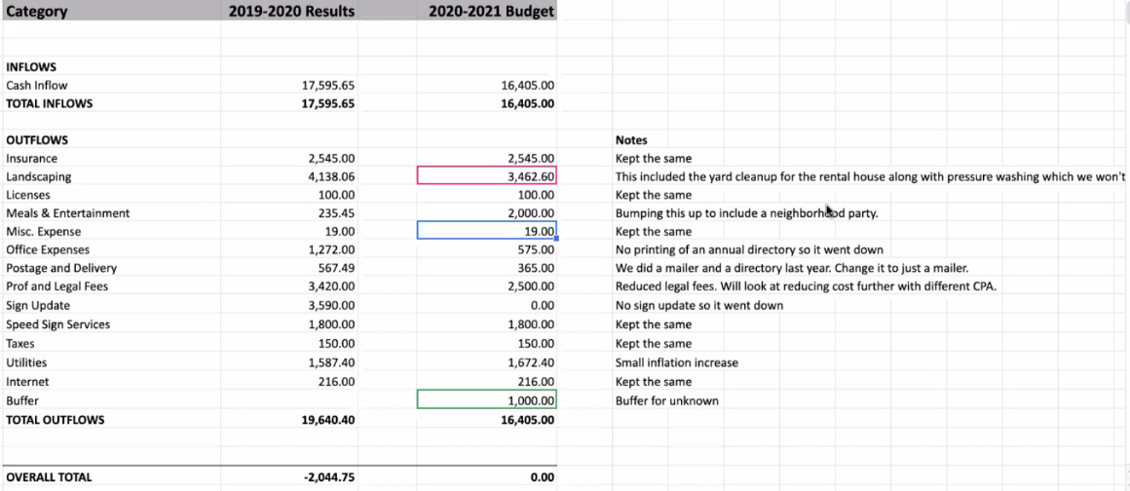
- Question: could we get reimbursed for property landscaping fees on the houses that were rentals and under need of bringing into compliance? Yes, we were completely reimbursed for what was done.
ACC
- Charlie provided a year-in-review update.
- We’ve had 20 approved requests, and two pending, which consisted of the usual topics.
- Some neighbors are now installing solar panels, which is an uptick in the neighborhood from what we’ve seen previously.
- Paint colors will be more scrutinized in the future, and revisit the approval process and what colors are acceptable. In general, earth colors and acceptable.
- In general, the committee is running smoothly. Responses to requests are usually returned within a short amount of time. Requests can be approved within as little as one day.
- The ACC or Board does not make recommendations for contracting work; it is also a legal liability for the HOA.
- Anything being changed on the outside of your home are things that should be submitted for ACC approval. Painting, replacing windows, fences, etc. are architectural changes that are required to be approved.
- Question: What are the remediation processes for residents that haven’t gone through the ACC for changes? We are usually notified by neighbors. An ACC committee member may then go back and ask for an after-the-fact request for documentation. If there are further issues, it then passes to the Board.
Board Member Elections
- We need to vote in four of the five board members.
- Bill Lazar has been approved as taking on the role of President.
- Aaron Reiter has been approved as taking on the role of Treasurer.
- Andrea Thomsen has been approved as taking on the role of Secretary.
- Rob Marreel has been approved as taking on the role of Director.
New Business
Open - Traffic management on Peachtree (Maureen McKnight)
Maureen has been tracking speeds and worked with the County and the traffic engineers. There is no permanent speed sign on Peachtree. Here data shows 67% were going over 25, 19% were going over 30, and some were over 40 MPH. It seems that Peachtree has become more of a connector between Bull Mountain and Beef Bend roads. What has the Board done successfully and unsuccessfully thus far?
Peachtree is way too steep for stop signs. Speed bumps were deemed not possible. Traffic circles were voted on and it did not pass. The thought about traffic circles was viewed as a negative. Michelle Schneider did the survey 14 years ago. They felt that it was admitting that we had a speeding problem. It was a small amount of people that showed up and voted it down.
Richard Muffler moved in last year and have concerns as well about speeding and having young children playing around. Mark Weggeland asked if the traffic routing and construction has potentially caused more issues? Has GPS caused more traffic as shortcuts through the neighborhood?
Should we ask the County for more permanent speed signs? Aaron commented on making sure that concerned neighbors contact the police and submit their concerns.
Open – Pedestrian crossing on Peachtree/Bull Mountain
The concern is that there is no sidewalk and it is dangerous to try to cross.
When last checked (2017-18) by the Board, the property owner was not willing to give up land for a sidewalk.
WaCo has an approach called “Complete Streets.” It is a way for residents to provide a transportation network that addresses the needs of all road users, including pedestrians, bicyclists, motorists and transit riders. This is something maybe the HOA can take a look at.
CP4 Meetings – this area is a high-traffic area. Consider working with the County to put in a lighted walkway with flashing lights. An “organized voice” may be helpful.
We got a street improvement request in place. Unfortunately, it didn’t make the priority cut for the budget. The homeowner did not want to contribute the land to have a sidewalk put in. WaCo and City of Tigard both are involved.
Tree Trimming Guidelines
Topping of the maple trees is not allowed and in violation of our CC&Rs. We need to keep the maples in good shape. The branches are getting low in some places and the garbage trucks are damaging them. The HOA previously looked into having all the trees trimmed in the neighborhood, but it was deemed cost-prohibitive. As a reminder, please have your trees pruned adequately and safe for sidewalk safety, as well as the overall look of our neighborhood.
Meeting was adjourned at 8:41 PM.

